http://www.getty.edu/education/teachers/classroom_resources/curricula/stories/
The Musicians' Brawl
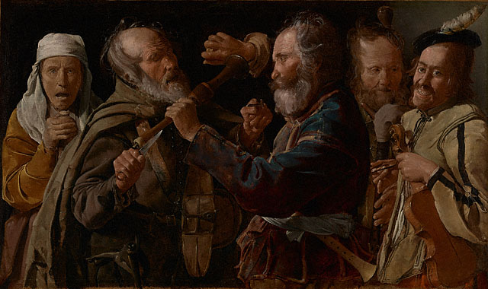
This image is available for download, without charge, under the Getty's Open Content Program.
Georges de La Tour
French, about 1625 - 1630
Oil on canvas
33 3/4 x 55 1/2 in.
72.PA.28

Two street musicians fight, perhaps over a place to play their instruments. The man on the left, wearing a hurdy-gurdy slung around his shoulders, defends himself with a knife and the crank of his instrument. The man in the center hits him with a shawm, a precursor to the oboe, and squeezes a lemon into his eyes to determine the legitimacy of the old man's blindness. To the right, two more itinerant musicians laugh and grin, enjoying the fight. An anguished old woman grasps the top of her broom and watches from the left. She wears a pleading expression, as if begging them to stop their quarreling.

The figures are compressed in a shallow space, pushed up close to the viewer to create a sense of claustrophobia and add to the immediacy of the scene. Georges de La Tour describes each character and his or her expression in great detail: rotting teeth, leathery skin, and wild, unfocused eyes. Different textures--fabrics, wood, hair and flesh--are minutely observed and realistically painted.

